Ideation Phase
Define the Problem Statements

Date | September 2026
Project Name | ServiceNow-Based Employee Laptop Request Application

:Customer Problem Statement Templet
Create a problem statement to understand the employee's point of view. The Customer Problem Statement template helps focus on the challenges involved in requesting, approving, tracking, and fulfilling company laptop requests through ServiceNow.
A well-articulated problem statement helps the team understand the challenges faced by employees, approvers, and IT administrators and supports the design of a centralized, transparent, and efficient laptop request process.
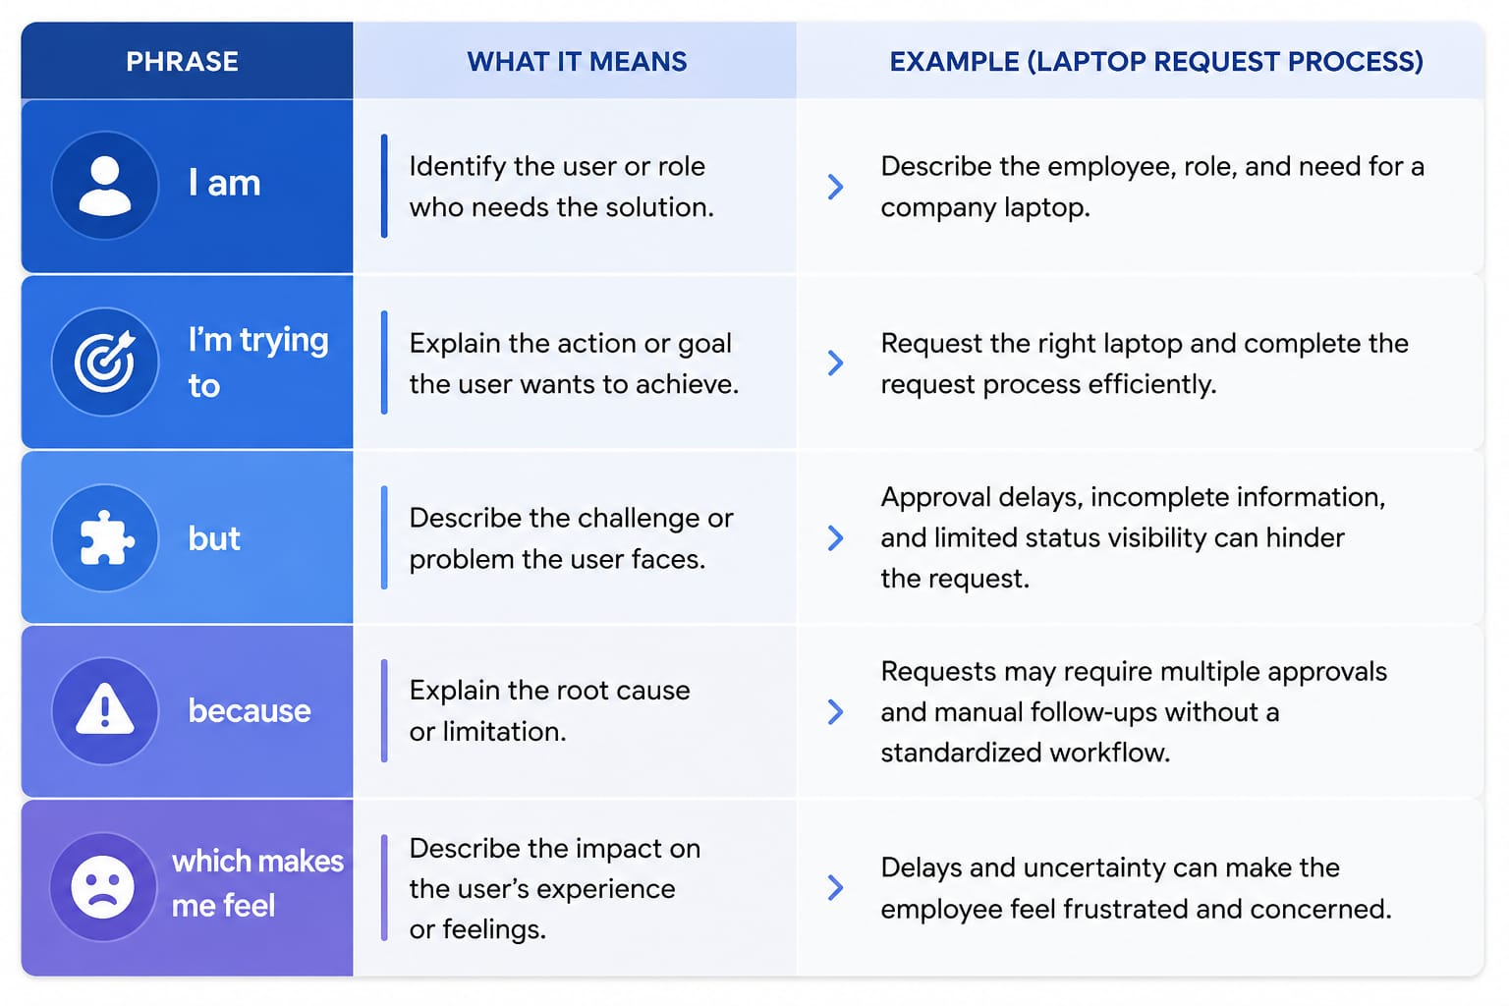
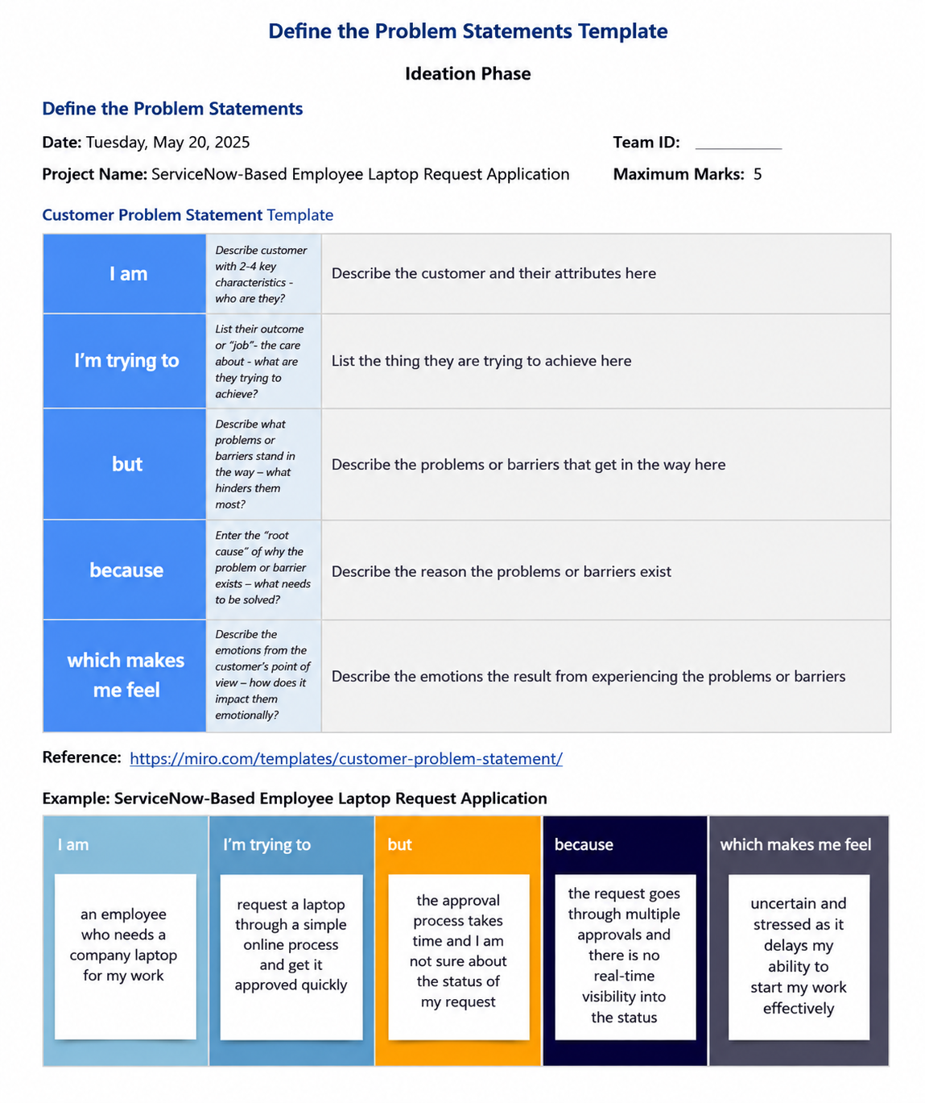
Reference: https://miro.com/templates/customer-problem-statement/

EXAMPLE:
